**Football Performance Enhancer**

**Business Case**

In the dynamic world of modern football, with the help of artificial intelligence, clubs and players can supplement the team’s performance and goals by inculcating data driven techniques to analysis the match and improving upon the key aspects. This help the clubs to strategize, maintain optimum performance of the players and scout selection.

Nowadays it is hard to analysis the performance of the footballer, and it’s hard for footballers to reach the next level because there are no effective ways to gather all the data from different aspects of the game and come with a meaningful insight.

However, with the help of machine learning and pattern recognition we collect data, along with that, for each individual we create a unique profile. Adding to that with help of drone we analysis the game and come up with key data sets which can be used to fine tune the game. Information like ball possession of each team, key chances created, defense and attacking line transitions, team structure. With all these information we can understand the game in depth and help the players to be better.

Moreover, the information also helps coach to give specific drills for each session and recommend diet plan to players if needed. Also managers can come up with more effective and decisive tactics. This will have a significant impact on the player’s physical and mental wellbeing. Above all teams overall performance and goals

**Available features**

* Unique profile for every players
* Coach and manager interaction with players
* Diet plans and physiotherapy sessions
* Drill suggestions and team planning
* Data collected on ball possession
* Attacking and defending line transitions
* Key chances created
* Goal scoring opportunities

**Key pillars of the program**

Managers

Handles the technical and tactical side of the game with the help of the data collected and using the players effectively.

Coach and Assistant coach

Gives drills based on the team’s performance, requirement and enhancing the skills of certain players if needed any. Also guiding diet, gym, rehabilitation.

Dietitian, Gym trainer and Physiotherapist

Gives the specified diet plan for each players.

Special gym session for each players based on the position they play in.

Managing overall physical and mental health.

Players

Are the individual players who sign up for the program

Administrator

Handles the whole system and make necessary changes for the best reuslts.

Expected outcomes

* Analytic on the data for team enhancement.
* Overall player and team development
* Calculate the effectiveness of the training
* Helping to organize the game better
* Making contestants physically and mentally healthy
* Helping to win matches
* Helping to increase the quality of the game

ER model construction

Step1: Entity

* Players
* Coach
* Manager
* Physiotherapist
* Dietitian
* Gym trainer
* Game data
* Player data
* Team data

Step2: attributes

Players: Name, id, contact number, address, age, email,position

Coach: Name, id, contact number, address, age, email

Carrier achievement, previous clubs

Manager: Name, id, contact number, address, age, email, Carrier achievement, previous clubs

Physiotherapist: Name, id, contact number, address, age, email, experience

Dietitian: Name, id, contact number, address, age, email, diet plan

Gym trainer: Name, id, contact number, address, age, email, special workout based on their position

Assistant coach: Name, id, contact number, address, age, email, Carrier achievement, previous clubs

Game data: ball possession, key chances created, goal scored, pass completion, interception, broke the defense line, assists, yellow cards, red cards

Player data: touch on the ball, pass completed, pass received, pass missed, goal scored, key passes, interception, play time, position individual play in, health status

Step 3: relationships

Football has players

Football has mangers

Managers have coaches

Coaches have assistant coach

Coaches have physio

Coaches have gym trainers

Coaches have dietitian

Football maintain game data

Game data maintain team data

Step4: cardinality

Football has players 1:M

Football has mangers 1:1

Managers have coaches 1:1

Coaches have assistant coach 1:1

Coaches have physio 1:1

Coaches have gym trainers 1:1

Coaches have dietitian 1:1

Football maintain game data 1:M

Football maintain player data M:M

Step 5 entity if weak

There are no weak entity

Step 6 identify the participation

Football has players = both have total participation

Football has mangers =football partial and manager total

Managers have coaches =managers partial coaches total

Coaches have assistant coach = coaches partial assistant coach total

Coaches have physio =coaches have partial physio total

Coaches have gym trainers = coaches partial gym trainers total

Coaches have dietitian = coaches partial dietitian total

Football maintain game data = football partial game data total

Game data have player data= both total participation

ER DIAGRAM

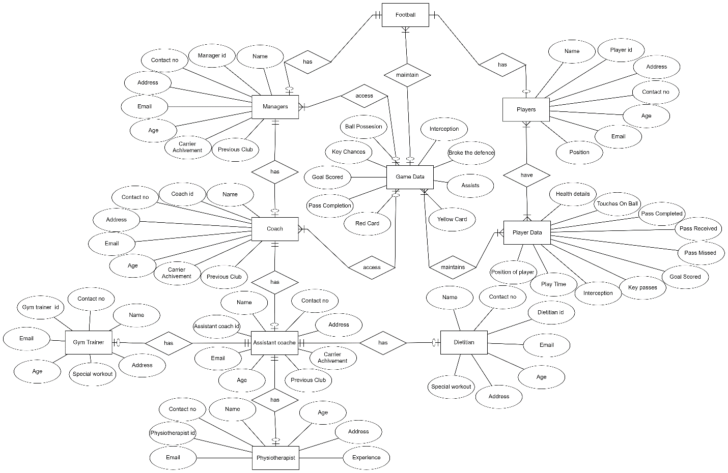

**Operations**

Football

* Can give access to the game data, revoke and grant
* Controls all the other entity can performance addition or deletion of an entity for instance a player or a coach
* Maintains the overall database

Managers

* Managers can access all the games data
* Managers can view each attributes or combined attributes of the game data like, ball possession, key chances created, goal scored, pass completion, interception, broke the defense line, assists , yellow cards, red cards
* Managers can also access all the player data
* Mangers can also view each attributes like, touch on the ball, pass completed, pass received, pass missed, goal scored, key passes, interception, and play time. These information can be selected for a particular player or a group of player based on the position they play in.
* Managers can access information about coaches, assistant coaches, dietician, and physio and gym trainer.

Players

* can add there information the data base
* all the players performance details are available in player data
* Players can communicate with coach, assistant coach, physio, gym trainer, and dietitian.

Assistant coach

* Can access some inform from game data and player data.
* Can give suggestions if any
* Can give assistance to physio, dietitian and gym trainer

Physiotherapist

* Can work on the area where assistant coaches ask with respect to their field.
* Have to help the players to be in there best state before the match.
* Have to give special care to injured players or weak players
* Can work in relation with dietitian, assistant coach and gym trainer

Dietitian

* Can work on the area where assistant coaches ask with respect to their field.
* Have to help the players to be in there best state before the match.
* Special diet for maintain the optimum performance of players
* Can work in relation with assistant coach, physio and gym trainer

Gym trainer

* Can work on the area where assistant coaches ask with respect to their field.
* Have to help the players to be in there best state before the match.
* Special training based on the players position and conditioning
* Can also work with assistant coach, physio and gym trainer

**Information**

* We can collect information on game data like, key chances created, goal scored, pass completion, interception, broke the defense line, assists, yellow cards, red cards and
* Player data: touch on the ball, pass completed, pass received, pass missed, goal scored, key passes, interception, play time, position individual play in, health status
* These information can be clubbed together based on the needs and come up with great insights like,
* we can collect the information of specific player
* or certain players in a particular position
* the highest goal scoring player
* who has more time on the ball
* which player are consistent
* players likely to get injured
* players with vision
* players are good in interception
* which players can be selected to the main team
* heat map of where the game mostly occurred
* pass completion state between each players
* defending and attacking transition
* if a player is active on the pitch or not
* ball winning stats
* possession of both teams
* goal scoring percentage of each player
* dribbling percentage of each player
* defense percentage of each player
* speed of each player
* passing percentage of each player
* physical attributes of each player
* corners who scores more
* goal scored inside the box
* goal scored outside the box
* penalties